

INFORMATICS INSTITUTE OF TECHNOLOGY

In Collaboration with

UNIVERSITY OF WESTMINSTER

**6MARK017W: Digital Marketing, Social Media & Web Analytics**

**Coursework 01**

**Ms. Noorul Amaanie Yoosuf**

**BSc (Hons) in Computer Science**

School of Computing & Engineering

College of Design, Creative & Digital Industries

University of Westminster

05.03.2024

# Table of Contents

Table of Contents i

List of Tables ii

List of Figures ii

List of Abbreviations ii

Question 01 – Digital Marketing Models 1

Question 02 – Search Engine Optimization 4

Question 03 – Social Media & Traditional Marketing Methods 5

References I

Appendix i

# List of Tables

# List of Figures

Figure 1 : Digital Marketing Funnel (Self-composed) 1

# List of Abbreviations

|  |  |
| --- | --- |
| **Abbreviation** | **Acronym** |
|  |  |
|  |  |
|  |  |
|  |  |

# Question 01 – Digital Marketing Models

**Daraz** has been selected as the online company by the author for this case study. The discussion which follows will be based on the stated ecommerce company.

A digital marketing funnel depicts the customer’s journey and buying stages one goes through after a business, service or product awareness (The Marketing Funnel: What It Is & How It Works, no date).

The funnel method introduced by Ash in 20212 has been widely used to guide customers from their product/service awareness stage and until a purchase in made. A detailed explanation of each stage of the Ash’s funnel process is presented below.

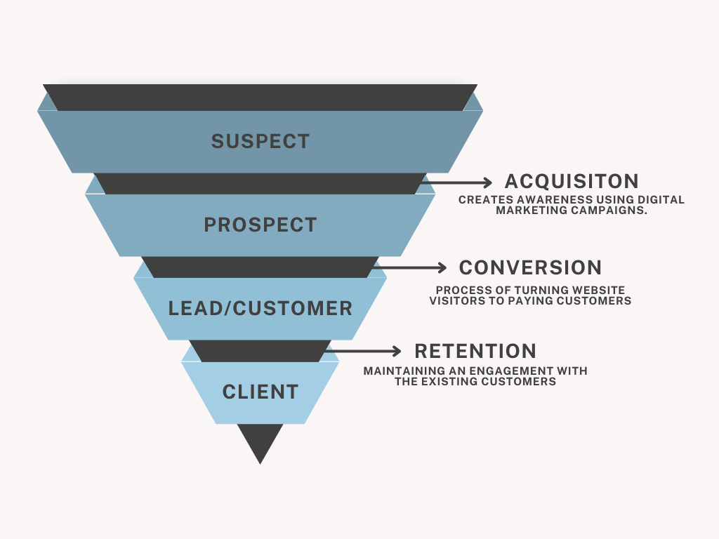

Figure : Digital Marketing Funnel (Self-composed)

**The significance of each stage in Ash’s Funnel has been presented below.**

**Suspects**

Individuals that have no prior affiliation with the organization, product or service provided. Further, they present no clear tendency towards potential future purchases (Kingsnorth, 2022).

**Acquisition**

During this stage, individuals (potential customers) are made aware of the establishment and learn about it via digital marketing campaigns such as, google searches, banner advertisements, email and social media marketing and other similar channels (The Digital Marketing Funnel Stages, Explained – First Page Sage, no date).

**Prospects**

These individuals are characterized by their initial expression of interest towards the product. Their interest could be demonstrated in multiple ways and aspects such as, visiting websites, subscriptions to services offered, and through inquiries (Kingsnorth, 2022).

**Conversion**

A prospect reaches this stage of the funnel when they have made a decision that the products and services offered by the organization align with their needs and requirements (The Digital Marketing Funnel Stages, Explained – First Page Sage, no date). It is during this stage that the prospect converts themselves into a customer once the initial purchase with the organization is established.

**Leads**

Entities that depict an in-depth interest towards purchasing the product or service offered by the organization. Leads exhibit their interest towards the organization’s services offered by filling out forms and signing up their newsletters. However, leads, shows potential in becoming a customer (Digital Marketing Funnel: What Is It and How To Create an Efficient One, no date).

**Customers**

Upon completing the first purchases, entities transfer from leads to customers. From this moment of transactional engagement, a relationship will be established with the customer and the organization (Kingsnorth, 2022).

**Retention**

After the initial purchases has been made by the customer, it is essential to retain these existing customers due to multiple reasons, such as, acquiring new customers could be costly and customer retention is important to the organization since it depicts their trust bondage and treatment of existing customers. These customers can be retained by providing them with coupons, discount and email promotions (Digital Marketing Funnel: What Is It and How To Create an Efficient One, no date).

**Clients**

Customers that have progressed beyond their initial purchase or transaction are entitled the term ‘Client’. Clients engage in repeated business with the establishment. Although there is no brand advocating conducted (Kingsnorth, 2022).

**The applicability of Ash’s Funnel Method on Daraz’s Business Model has been evaluated below.**

**Acquisition Methods**

It is during this stage that prospective customers are made aware on the brand. Presently, most acquisition methods involve digital marketing campaigns.

Similarly, Daraz can make their potential customer base aware by advertising about the organization and its products and services via social media campaigns, banner advertisements and affiliated marketing which includes collaboration with recognized social media personalities. Hence, prospective customers could explore the services offered and products in-store. Further, email marketing plays a pivotal role in guiding prospects during this stage.

**Conversion**

This stage focuses on persuading prospects to take action in becoming a lead or customer.

Although there are multiple types of conversion actions such as; purchasing a product, signing up to a newsletter, etc… Using mediums such as personalized communication, exclusive offers and promotions, authentic reviews and user experience; Daraz could convert these potential entities into customers.

**Retention**

The conversion of prospects into customers isn’t sufficient for the succession of a business or organization. Hence, post-purchase relationships with the customer is important for Daraz to retain the customer-based created.

In order to encourage repeat purchases, Daraz can provide their customers with loyalty programs, personalized recommendations exclusive invitations for company-organized events and seamless customer service.

To conclude, using the digital marketing funnel process can be effective for Daraz in guiding their customer’s shopping journey from acquisition to retention.

**Definition of technical terms used**

|  |  |
| --- | --- |
| Technical Term | Definition |
| Entity | An individual with its own identity. |
| Transactional Engagement | Interactions where exchanges such as, purchases/negotiations take place between parties. |
| Social Media Campaigns | Strategic activities on social media platform which assist in achieve business goals. |
| Email Marketing | Sending out of email to promote products, services or to build customer relationships. |
| Banner Advertisements | Digital advertisements displayed on other websites to attract a wider user attention. |
| Post-purchase | Interactions with customers after a purchase is made. |
| Loyalty Programs | Strategies to reward customers for their repeated engagement with the organization, product or service. |

Table : Technical Terms and Definitions

# 

# Question 02 – Search Engine Optimization

# Question 03 – Social Media & Traditional Marketing Methods

# References

Digital Marketing Funnel: What Is It and How To Create an Efficient One. (no date). Available from https://rockcontent.com/blog/digital-marketing-funnel/ [Accessed 17 February 2024].

Kingsnorth, S. (2022). *Digital marketing strategy: an integrated approach to online marketing*, Third Edition. London ; New York, NY: Kogan Page Limited.

The Digital Marketing Funnel Stages, Explained – First Page Sage. (no date). Available from https://firstpagesage.com/seo-blog/digital-marketing-funnel-stages-fc/ [Accessed 17 February 2024].

The Marketing Funnel: What It Is & How It Works. (no date). *Semrush Blog*. Available from https://www.semrush.com/blog/marketing-funnel/ [Accessed 17 February 2024].

# Appendix